Sistemas Informáticos (Computer Systems)  
Unit 07. Hardware: Internal components - Part 1

short line

Authors: Sergi García, Alfredo Oltra

Updated December 2022

Licencia

**Reconocimiento - No comercial - CompartirIgual** (BY-NC-SA): No se permite un uso comercial de la obra original ni de las posibles obras derivadas, la distribución de las cuales se ha de hacer con una licencia igual a la que regula la obra original.

Nomenclatura

A lo largo de este tema se utilizarán diferentes símbolos para distinguir elementos importantes dentro del contenido. Estos símbolos son:

📖 **Important**

❕ **Attention**

💬 **Interesting**

**INDEX**

**1. Motherboard** **3**

**1.1 Form factor** **3**

**1.1.1 Reduced formats** **5**

**1.1.2 Which form factor to choose?** **5**

**2. Elements of motherboard** **5**

**2.1 Sockets** **6**

**2.2 Voltages** **6**

**2.3 BIOS and UEFI** **6**

**2.4 Battery** **6**

**2.5 Processor/Component Communication Buses** **7**

**2.6 Chipset** **7**

**2.7 Expansion slots** **8**

**2.8 Connectors** **8**

**2.9 Processors** **10**

**2.10 Fans and heat sinks** **11**

**2.11 RAM Memory** **11**

**2.11.1 RAM Memory types** **11**

**2.11.2 DDR Memory** **12**

**2.12 Cache memory** **12**

**3. Bibliography** **13**

**4. Bibliography** **13**

Unit 07. Hardware: Internal components - Part 1

# Motherboard

The motherboard, also known as *MoBo*, is a printed circuit board where the computer components are connected. It tends to give more Importance to other elements such as the microprocessor or memory, but the motherboard is critical: what and how many components can be installed in the computer depends on it.

💬 **Interesting:** At first, each motherboard could hold a specific model of processor (CPU) but from any manufacturer (Intel, AMD, Cyrix, etc.). But since 2004, although the processors were compatible in functionalities, manufacturers were differentiating their models in the pinout, so the motherboard has to be specific to each type of processor ever since.

It has installed a series of integrated circuits, including the chipset which serves as a hub between the microprocessor, random access memory (RAM), expansion slots and other devices. All the components of the motherboard are connected with “paths” whose name is buses.

Besides, the motherboard includes a firmware (software stored in a read-only memory like EEPROM, flash, ...) called BIOS in old teams and called UEFI in modern motherboards, which lets you perform basic functions such as testing devices, video and keyboard operations, recognition devices and operating system load.

💬 **Interesting:** More information about BIOS and UEFI in <https://es.wikipedia.org/wiki/BIOS> and <https://es.wikipedia.org/wiki/Unified_Extensible_Firmware_Interface>

The motherboard is a device on which the other components of the PC are mounted and whose main function is to serve as a communication channel between the aforementioned components, providing the necessary electrical lines and control signals. Some functions that it does:

* Physical connection.
* Administration, control and distribution of electrical energy.
* Data communication.
* Timing.
* Synchronism.
* Control and monitoring.

## Form factor

A personal computer is made up of several independent elements. For example, motherboard, case, power supply, etc. Each of these components is provided by a separate manufacturer. If there were no minimum agreement between manufacturers, it would not be possible to interoperability of these components. For example, a motherboard could not physically enter into the casing, or a power supply plug could be incompatible with the connector on the motherboard. One of these agreement, it's a standard called *form factor*. The features that define one form factor are:

* The shape of the motherboard: square or rectangular.
* Their exact physical dimensions: width and length.
* The position of the anchors. That is, the coordinates where the screws are positioned to anchor it to the casing.
* The areas where certain components are located. Specifically, the expansion slots and the rear connectors (keyboard, mouse, USB, etc.)
* The electrical connections of the power supply, that is, the number of power supply wires that the motherboard requires, their voltages and function.

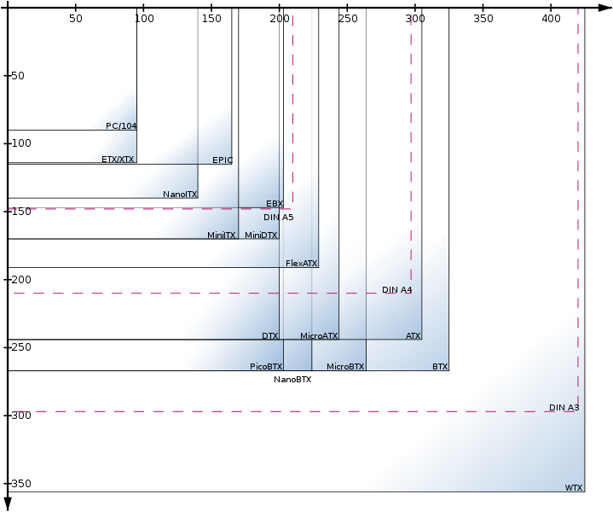

*Figure 1 - Comparative table of several motherboard form factors.*

As you can see from the table below, there are many form factors, and many more that are appearing with new devices such as tablets and phones

Among all form factors, perhaps the ATX and its variants are the best known. Its name comes from AT eXtended, because it replaces the former AT form factor, adding several features to improve its functionality:

* Dimensions: 305x244 mm.
* A connector for the power supply which prevents incorrect connection.
* The connectors are laid out better to reduce cable length.
* It improves the components’ layout, rotating the motherboard 90º and placing the CPU and memory near the fan power supply and away from expansion cards (thus allowing the connection of larger cards).
* A connection and disconnection system of the computer through software.

💬 **Interesting:** Although it seems strange, not too many years ago, it was impossible to turn off the computer from the Operative System (OS). The computer turned off like a light bulb, with a switch.



*Figure 2 - ATX form factor.*

### Reduced formats

A lot of form factors have their smaller size versions. Today, most users hardly use expansion cards due to elements such as sound and network cards are integrated into the motherboard. Therefore, removing the expansion slots to gradually reduce the size makes sense.

One of the small format that is most successful is the Mini-ITX (170x170 mm), which typically includes at least one expansion card and many embedded devices.

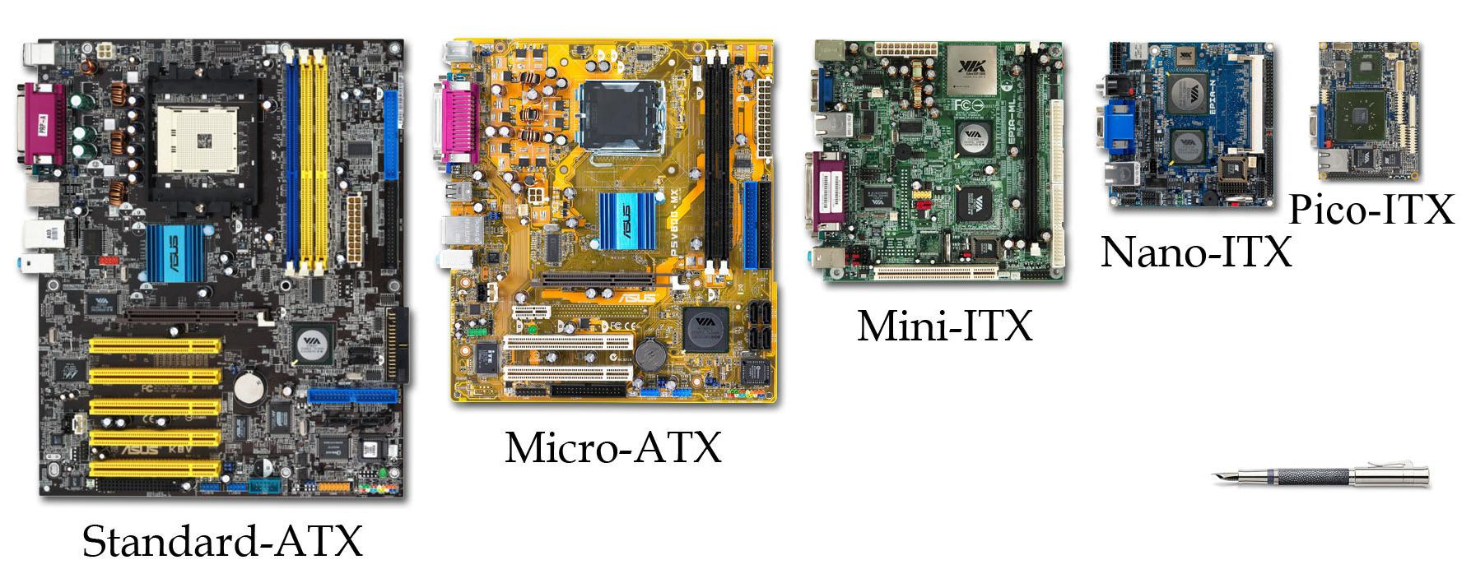

*Figure 3 - Comparative table of several motherboard form factors.*

### Which form factor to choose?

Ultimately, the best form factor for any given situation will depend on a variety of factors, including the intended use, budget, and desired features and capabilities.

For example, in industrial context, ATX form factor motherboards are generally considered to be the best option. This is because ATX motherboards offer the most robust feature set and support for a wide range of components, making them well-suited for demanding industrial applications. In addition, ATX motherboards typically have more expansion slots and support for a wider range of peripherals, which can be important in industrial settings where a variety of specialized devices may need to be connected. Overall, the ATX form factor provides the flexibility and expandability that are often necessary in industrial environments.

But in industrial context, usually you want some machines (for example, using them as controller of a situation) to be a low consumption machine, in this case, you can use Pico-ITX.

For gaming, also it depends on: it is recommendable for cooling purposes to use an ATX motherboard, but if you want some portability, you can use Mini ITX.

Summarizing, it depends on each purpose, situation and budget.

# Elements of motherboard

The main elements of a motherboard are:

* The microprocessor socket.
* Memory sockets.
* Internal and external connectors.
* Expansion slots.
* Chips that perform various PC tasks.
* The battery, a small battery whose function is to maintain power to the real-time clock (RTC) and various parameters used by the BIOS.

## Sockets

Hardware components are inserted into these sockets. There are two types of sockets:

* **Processor sockets.**
  + Intel and AMD.
  + They can be SLOT (longitudinal, older) or SOCKET (rectangular).
  + Currently, the Sockets used by INTEL are LGA 1150 and 1151. Those used by AMD are AM4, AM3+ and FM2+ (This is especially for processors that include an APU <https://es.wikipedia.org/wiki/Accelerated_processing_unit>).
  + When a microprocessor is installed on a motherboard, one configurable parameter is the base frequency of its operation and the multiplier, which is the factor by which the base frequency is multiplied. This gives the actual operating frequency. <https://es.wikipedia.org/wiki/Multiplicador_de_CPU>
* **RAM memory sockets**
  + Sockets for RAM memory are typically:
  + **SIMM** (Single In-line Memory Module). Older ones.
  + **DIMM** (Dual in-line Memory Module). They replace SIMMs.
    - 168-pin DIMMs, SDR SDRAM (types: PC66, PC100, PC133...).
    - 184-pin DIMM, DDR SDRAM (up to 1 GiB per module).
    - 240-pin DIMM, DDR2 SDRAM (up to 4 GiB per module).
    - 240-pin DIMM, DDR3 SDRAM (up to 8 GiB per module).
    - 288-pin DIMMs, DDR4.
  + **SO-DIMMs** (Small Outline DIMMs) consist of a compact version of DIMMs that have 100, 144 or 200 pins. The 100-pin DIMMs support 32-bit data transfers, while the 144- and 200-pin DIMMs support 64-bit data transfers.
  + **Micro-DIMM**: Smaller than SO-DIMM. Used for small notebook computers, such as netbooks.

## Voltages

The motherboard generally manages voltages between 5V for the processor and 12V for the rest. By means of voltage regulator modules, the voltages are adapted to the needs of the processor and board (generally lower than the amount provided for efficiency reasons). <https://es.wikipedia.org/wiki/VRM>

## BIOS and UEFI

BIOS: Basic Input/Output System is an interface between the hardware and the operating system.

Its functions are to perform initial boot checks, load a bootloader and provide an abstraction layer between the operating system and the hardware.

BIOS systems have been replaced by UEFI (with greater support for modern peripherals, graphical interface, remote tunability, support for GPT partitioning (to create partitions up to 8 ZB, etc.).

More information at:

<https://es.wikipedia.org/wiki/BIOS>

<https://es.wikipedia.org/wiki/Extensible_Firmware_Interface>

## Battery

Many motherboards have a battery to power the internal clock and the CMOS memory with BIOS parameters.

On some modern motherboards, the CMOS is stored in non-volatile memory and does not require the battery to store its contents.

## Processor/Component Communication Buses

The oldest and most prevalent is FSB (Front Side Bus). The FSB allows the exchange of information between the microprocessor, the memory and the I/O system.

Now replaced by:

* Intel QuickPath Interconnect <https://es.wikipedia.org/wiki/Intel_QuickPath_Interconnect>
* HyperTransport on AMD <https://es.wikipedia.org/wiki/HyperTransport>

In these buses, two frequencies must be differentiated: internal and external.

* The processor cycle rate or internal frequency.
* The communication bus speed or External Frequency.

The factor that measures the ratio between the internal speed and the external speed is known as the "CPU multiplier".

## Chipset

The Chipset is a set of chipsets with specific functions. The characteristics of each Chipset vary with the motherboard. Generally, motherboards tend to have two main types of chipsets. The North bridge (recognizable by having a large heat sink and being physically close to the memory, processor and video card) and the South bridge (without a heat sink or with a smaller heat sink).

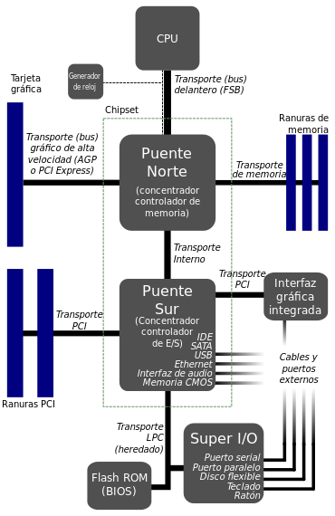

*Figure 4 -North and Sout bridge*

Their main functions on most motherboards are:

* **North bridge**
  + Controls information exchanges between microprocessor, RAM and graphics card.
* **South bridge**
  + Controls the information exchanges that occur between the processor and the I/O system.
  + Differentiate the type of bus and its physical interfaces and connectors.
  + By means of a collaboration with the north bridge, it performs DMA (Direct Memory Access) tasks.

The degree of obsolescence of a board depends on the chipset because it is soldered and cannot be changed, as well as on the degree of updating of connectors and I/O buses.

## Expansion slots

The main expansion slots are:

* **ISA** (Industry Standard Architecture). Old: Parallel Bus. There were 8-bit and 16-bit, reaching speeds of up to 16 MB/s. ISA cards and derived IRQ interrupts had to be configured manually via jumpers.
* **EISA** (Extended ISA). Old: Parallel bus. Used a 32-bit bus and achieved 33 MB/s.
* **VESA** (Video Electronics Standard Association). Old: Parallel bus that came out to support the emerging external video cards. It worked at 4 bits and frequencies between 33-40 MHz.
* **PCI** (Peripheral Component Interconnect): Parallel bus. Widespread and still used for components that do not require high bandwidth. Interrupts (IRQs) are automatically configured by the BIOS. PCI versions:
  + PCI 3.0: the last PCI standard, working in 3.3 volts.
* **AGP** (Accelerated Graphics Port). Old: Parallel Bus. A bus specification that provides a direct connection between the graphics adapter and the memory. It was generally used for graphics cards. Last AGP version: AGP 3.0: 0.8 volts, with 8 transfers per clock cycle at 66MHz (2013 MB/S).
* **PCI Express**: An enhancement of PCI mainly by taking advantage of the technological benefits of working in series. An improvement on PCI. Currently, the most widely used. In graphics, it has replaced AGP. Each expansion slot carries one, two, four, eight or sixteen data lanes between the motherboard and the connected cards (these are referred to as 1x, 2x, 4x, 8x and 16x). PCI Express versions:
  + PIC Express 1.0: 250 MB/s (×1) 4 GB/s (×16)
  + PIC Express 2.0: 500 MB/s (×1) 8 GB/s (×16)
  + PIC Express 3.0: 985 MB/s (×1) 15.75 GB/s (×16)
  + PIC Express 4.0: 1959 MB/s (×1) 31.51 GB/s (×16)

## Connectors

We will now discuss the most common connectors on today's motherboards.

* **USB (Universal Serial Bus)**: Serial bus, generally used as a standard for connecting peripherals. It is useful for connecting external devices that do not require an excessively high speed. This port provides power varying according to version.

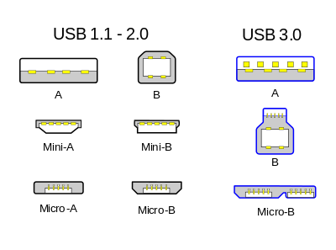

*Figure 5 - USB connectors.*

* + - USB 3.1 uses type C connectors that are reversible.

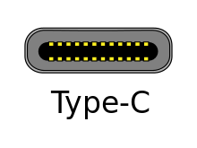

*Figure 6 - USB Type-C (Reversible)*

* **USB versions:**
  + USB 1.0: 1.6 Mb/s (200 KB/s)
  + USB 1.1: 12 Mb/s (1.5 MB/s)
  + USB 2.0: 480 Mb/s (60 MB/s)
  + USB 3.0: 4.8 Gb/s (600 MB/s)
  + USB 3.1: 10 Gb/s (1.2 GB/s)
* **HDMI** (High Definition Multimedia Interface) connectors: generally for connecting displays to the graphics card. The most commonly used at present.
  + HDMI versions:
    - HDMI 1.0: 4.9 Gb/s
    - HDMI 1.3: 10.2 Gb/s
    - HDMI 2.0: 18 Gb/s
* **DisplayPort**: DisplayPort is a digital device interface standard developed by the Video Electronics Standards Association (VESA) that is license and royalty free. With the latest revisions, an "Alternate Mode on USB Type-C connector" has been added that allows the DisplayPort specification to be included on a USB Type-C connector.
* **SATA** (Serial ATA) connectors: connectors generally used to connect devices such as hard disks or Blu-ray/DVD drives. SATA connectors are usually intended to be internal board connectors. There are other variants such as eSATA intended for connecting external SATA devices.
  + **SATA versions:**
    - SATA I: 150 MB/s
    - SATA II: 300 MB/s
    - SATA III: 600 MB/s
* **Thunderbolt**: are a series of high-speed connectors developed by Intel and Apple. They currently have speeds of 20 Gb/s, but could theoretically reach 100 GB/s in the future. It can be used for data transfer, video, etc. Thunderbolt 3 will use a Type-C connector.
* **Other connectors:**
  + **Older**:
    - COM1 and COM2
    - LPT
    - PS2
    - IEEE 1394 Firewire
  + **Graphics:**
    - VGA
    - DVI
  + **Hard Disk Drives:**
    - IDE
    - SCSI

## Processors

In this section, we will discuss current processor trends

* **Intel:**
  + **Core i3**: They have two cores and four threads.
  + **Core i5**: They have four cores and four threads. U" models have two cores and four threads.
  + **Core i7**: We have quad-core, eight-threaded processors that offer almost identical performance to the Core i5 in most cases (provided they use the same architecture). The "U" series models have two cores and four threads.
  + **Core i7 and Core i9 Extreme**: these are processors with between six and eighteen cores.

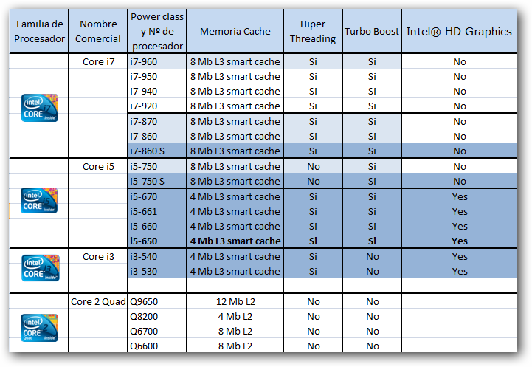

*Figure 7- Intel table comparison*

* **AMD:**
  + **APUs**: These integrate processor and GPU in the same package. The configurations are very varied, as we can find versions with processors from two to four cores and quite powerful graphics cores.
  + **FX 4300**: They have four cores.
  + **FX 6300**: They are a step above the previous ones, as they have six cores.
  + **FX 8300**: They have eight cores.
  + **RYZEN**: These are manufactured in a 14 nm process and have versions ranging from four cores and four threads to eight cores and sixteen threads.

An attempt is made here to make a rough equivalence between the latest generations of Intel and AMD processors. A table sorted hierarchically by performance can also be found at <http://www.aemulatrix.com/2017/04/tabla-comparativa-de-procesadores-amd.html> .

## Fans and heat sinks

Processors generally reach very high temperatures. To cool them properly, they are usually air-cooled (although there are other methods such as liquid cooling).

Air cooling is done by combining a heat sink + fan. The heat sink is attached to the processor with thermal paste (to improve heat transfer) and helps the heat to escape. The fan helps this process by introducing air to the heat sink and generating an airflow.

On this page you can find maximum temperature charts for the most common Intel and AMD processors and tips for proper cooling. <http://www.buildcomputers.net/cpu-temperature.html>

## RAM Memory

RAM is the main storage source with which the microprocessor communicates. It is a volatile read/write memory.

RAM memory has two main characteristics:

* RAM is used to store data temporarily, that is, until the computer shuts down or is restarted.
* Its access is random (in fact, RAM means Random Access Memory), that is, we can be accessed anywhere at any time.

We can imagine the memory like a big grid. To identify each cell, we use the address of the cell, or, in other words, the memory address. In each cell, the memory can save one bit. To work in an easier way, the computer puts in groups of 2n, with n>=3 n<=7. Each group is called word. The next figure shows an example of a memory of 4Kb (or 512B) with a word length of 8 bits:

The amount of memory that a computer can access depends on the width of the address bus. The maximum number of memory addresses that a processor can access is 2n, where n Is the bus width. Thus, in the x86 processor technology, the address bus has a width of 32 bits, that is, 232 addresses or, which is, 232 bytes = 4,294,967,296 bytes = 4GB. A processor with this technology may not take more than this amount of RAM. This is the main reason nowadays processors are 64 bits (to manage more RAM in one instruction).

### RAM Memory types

The two main forms of modern RAM are SRAM and DRAM. Both are volatile (they need power to hold the information). Their main difference is that SRAM does not require refresh circuitry and DRAM does, as it is capacitor-based and needs to dynamically refresh its charges:

* **SRAM (Static Random Access Memory)**:
  + Volatile.
  + Non-volatile:
    - **NVRAM** (non-volatile random access memory), non-volatile random access memory.
    - **MRAM** (magnetoresistive random-access memory), magnetoresistive or magnetic random access memory.
* **DRAM (Dynamic Random Access Memory**):
  + Asynchronous DRAM (Asynchronous Dynamic Random Access Memory):
    - FPM RAM (Fast Page Mode RAM)
    - EDO RAM (Extended Data Output RAM)
  + SDRAM (Synchronous Dynamic Random-Access Memory)
    - Rambus:
      * RDRAM (Rambus Dynamic Random Access Memory)
      * XDR DRAM (eXtreme Data Rate Dynamic Random Access Memory)
      * XDR2 DRAM (eXtreme Data Rate two Dynamic Random Access Memory)
    - SDR SDRAM (Single Data Rate Synchronous Dynamic Random-Access Memory, Single Data Rate SDRAM)
    - DDR SDRAM (Double Data Rate Synchronous Dynamic Random-Access Memory, Double Data Rate SDRAM)
    - DDR2 SDRAM (Double Data Rate type two SDRAM)
    - DDR3 SDRAM (Double Data Rate type three SDRAM)
    - DDR4 SDRAM (Double Data Rate type four SDRAM). Its speeds range from 1600 to 2666 MHz.

### DDR Memory

DDR is currently the most widely used DRAM.

The nomenclature used to define DDR type memory modules (this includes DDR2, DDR3 and DDR4 formats) is as follows: DDRx-yyyy PCx-zzzz; where x represents the DDR generation in question; yyyy the frequency in MHz and zzzz the maximum data transfer rate per second, in MegaBytes, that can be achieved between the memory module and the memory controller.

The transfer rate depends on two factors, the data bus width (usually 64 bits) and the operating frequency. The formula used to calculate the maximum transfer rate per second between the memory module and its controller is as follows:

Transfer rate in MB/s = (Effective DDR frequency) x (64 bits / 8 bits per byte).

For example:

1 GB DDR-400 PC-3200: Represents a 1 GB (Gigabyte) module of DDR type; with a frequency of 400 MHz and a maximum data transfer rate of 3200 MB/s.

4 GB DDR3-2133 PC3-17000: Represents a 4 GB module of type DDR3; operating frequency of 2133 MHz and a maximum data transfer rate of 17000 MB/s.

More information at <https://es.wikipedia.org/wiki/Memoria_de_acceso_aleatorio>

## Cache memory

Cache memory is a fast access memory for the processor.

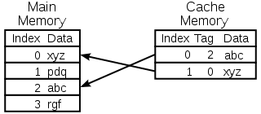

*Figure 8- Main memory and cache memory.*

It is a memory where the last data and instructions read from the RAM are stored, which allows the next access to be much faster.

The cache memory in current systems consists of:

* **Level 1 cache memory (L1 Cache)**: it is located in the core of the microprocessor. It is used to store and access important and frequently used data and instructions, speeding up processes, as it is the level that offers the shortest response time. It is generally divided into two sublevels.
  + Level 1 Data Cache: It is responsible for storing frequently used data.
  + Level 1 Instruction Cache: Stores frequently used instructions.
* **Level 2 Cache (L2 Cache)**: It is responsible for storing frequently used data, being slower than the L1 cache, but faster than the main memory (RAM). It is located in the processor, but not in its core.
* **Level 3 Cache (L3 Cache)**: This memory generates a copy to L2. It is faster than main memory (RAM), but slower than L2. This memory speeds up access to data and instructions that were not located in L1 or L2. It is generally larger and helps the system store large amounts of information, speeding up the processor's tasks. Nowadays, this memory is not used much anymore.
* More information at <https://en.wikipedia.org/wiki/Cache_(computing)>

# Bibliography

# Bibliography

[1] Tom's Hardware <http://www.tomshardware.com/>

[2] Hardware Comparisons <http://www.hwcompare.com/>

[3] Hardware articles <https://benchmarkhardware.com/>

[4] Computer Hardware Chart

<http://kingofgng.com/eng/2016/07/12/computer-hardware-chart-20/>